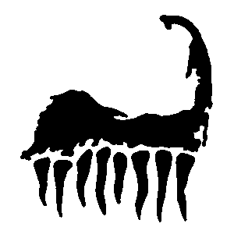

Notice of Race
33rd Annual Cape Cod Frosty North American Championship

Kittery Point Yacht Club – New Castle, NH
April 28-29, 2018

Information
Frosty Fleet 9
Commodore: Peter Devlin
devlin_peter@yahoo.com
978-943-7077

Schedule

Friday night Kick-off Fiesta 6pm at Kate and Eli’s

Saturday (11:07 high tide, 9.0 ft)
08:00 -09:00 Registration and Weigh-in [coffee and bagels]
09:00 -Skippers Meeting
09:30 - Harbor Start
10:00 - First Gun
16:00 – Grill Party at KPYC

Sunday (11:57 high tide, 8.9 ft)
09:30 - Harbor Start
10:00 - First Gun
16:00 – Awards ceremony at KPYC

Entry Fee is $45 per boat, $10 for additional guests for the Saturday Grill Party.

Rules
Racing Rules of Sailing, US Sailing Association, Sailing Instructions, and the rules of the Cape Cod Frosty Class Association.

